# EXP – 04 Face Recognition using Machine Learning CNN

**AIM:**

To develop a python on Face recognition using Machine learning CNN

**ALGORTIHM:**

Step 1: Getting Image dataset for our program

Step 2: Creating a mapping for index and face names

Step 3: Creating the CNN face recognition model

Step 4: Testing the CNN classifier on unseen images

**Program:**

TrainingImagePath='/Users/Joel/Python Case Studies/Face Images/Final Training Images'

from keras.preprocessing.image import ImageDataGenerator

train_datagen = ImageDataGenerator(

        shear_range=0.1,

        zoom_range=0.1,

        horizontal_flip=True)

test_datagen = ImageDataGenerator()

# Generating the Training Data

training_set = train_datagen.flow_from_directory(

        TrainingImagePath,

        target_size=(64, 64),

        batch_size=32,

        class_mode='categorical')

# Generating the Testing Data

test_set = test_datagen.flow_from_directory(

        TrainingImagePath,

        target_size=(64, 64),

        batch_size=32,

        class_mode='categorical')

# Printing class labels for each face

test_set.class_indices

# class_indices have the numeric tag for each face

TrainClasses=training_set.class_indices

# Storing the face and the numeric tag for future reference

ResultMap={}

for faceValue,faceName in zip(TrainClasses.values(),TrainClasses.keys()):

    ResultMap[faceValue]=faceName

# Saving the face map for future reference

import pickle

with open("ResultsMap.pkl", 'wb') as fileWriteStream:

    pickle.dump(ResultMap, fileWriteStream)

# The model will give answer as a numeric tag

# This mapping will help to get the corresponding face name for it

print("Mapping of Face and its ID",ResultMap)

# The number of neurons for the output layer is equal to the number of faces

OutputNeurons=len(ResultMap)

print('\n The Number of output neurons: ', OutputNeurons)

from keras.models import Sequential

from keras.layers import Convolution2D

from keras.layers import MaxPool2D

from keras.layers import Flatten

from keras.layers import Dense

'''Initializing the Convolutional Neural Network'''

classifier= Sequential()

''' STEP--1 Convolution

# Adding the first layer of CNN

# we are using the format (64,64,3) because we are using TensorFlow backend

# It means 3 matrix of size (64X64) pixels representing Red, Green and Blue components of pixels

'''

classifier.add(Convolution2D(32, kernel_size=(5, 5), strides=(1, 1), input_shape=(64,64,3), activation='relu'))

'''# STEP--2 MAX Pooling'''

classifier.add(MaxPool2D(pool_size=(2,2)))

classifier.add(Convolution2D(64, kernel_size=(5, 5), strides=(1, 1), activation='relu'))

classifier.add(MaxPool2D(pool_size=(2,2)))

classifier.add(Flatten())

classifier.add(Dense(64, activation='relu'))

classifier.add(Dense(OutputNeurons, activation='softmax'))

#classifier.compile(loss='binary_crossentropy', optimizer='adam', metrics=['accuracy'])

classifier.compile(loss='categorical_crossentropy', optimizer = 'adam', metrics=["accuracy"])

import time

# Measuring the time taken by the model to train

StartTime=time.time()

# Starting the model training

classifier.fit_generator(

                    training_set,

                    steps_per_epoch=30,

                    epochs=10,

                    validation_data=test_set,

                    validation_steps=10)

EndTime=time.time()

print("###### Total Time Taken: ", round((EndTime-StartTime)/60), 'Minutes ######')

import numpy as np

from keras.preprocessing import image

ImagePath='/Users/Joel/Python Case Studies/Face Images/Final Testing Images/face4/3face4.jpg'

test_image=image.load_img(ImagePath,target_size=(64, 64))

test_image=image.img_to_array(test_image)

test_image=np.expand_dims(test_image,axis=0)

result=classifier.predict(test_image,verbose=0)

#print(training_set.class_indices)

print('####'*10)

print('Prediction is: ',ResultMap[np.argmax(result)])

**Output:**

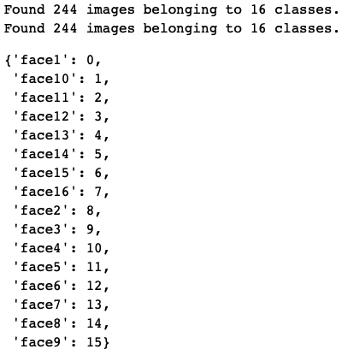

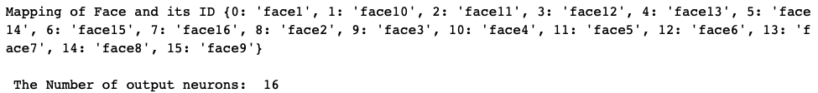

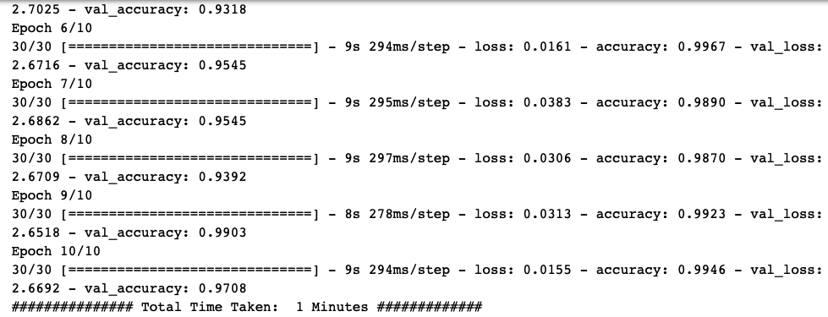



**Result:**

Thus, a python on Face recognition using Machine learning CNN has been built successfully.